Table of Contents
Groups 2
Prepare the sheet 2
Create groups 5
Visually grouping data 7
Create and modify sub-groups 7
Use group as filters 10
HIERARCHIES 13
Create HIERARCHIES 13
Discrete Custom Date Hierarchy (Years to dates) 14



Groups
Visually Grouping Data
Hierarchies

Groups

Prepare the sheet

Before we start grouping the data in our sheet, we should prepare some small graphic or bar for it.
Please load SSA-SA-FYWL.xlsx file or open Worksheet (SSA-SA-FYWL).tde at Tableau.
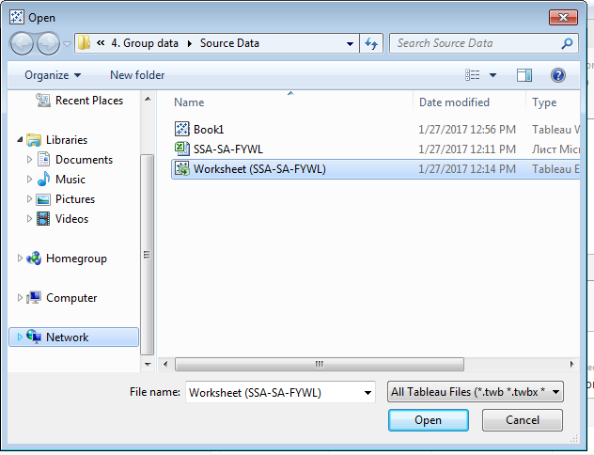

Change connection type to Extract.
Groups
Visually Grouping Data
Hierarchies
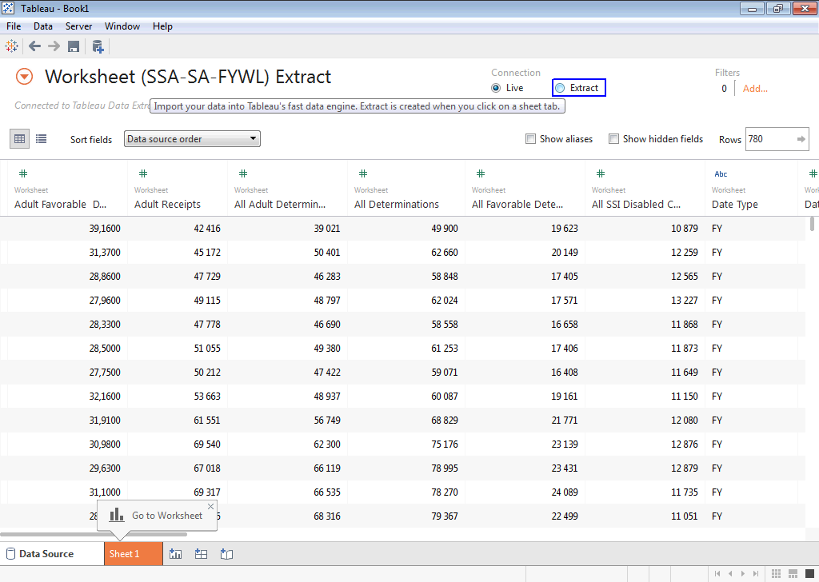
After it, open Sheet1. Click on “Cancel” at Save Extract As.
Note: if you load *.tde file, saving of new *.tde file during in swiching on some PAGES is not NECESSARY. Because *.tde file containce extraction from remote connection and under our example all data will be not changed.
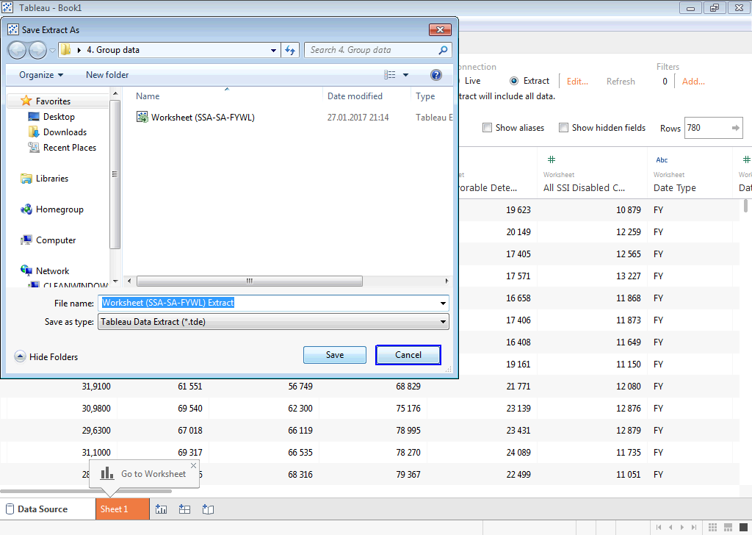

As a Columns we will use some numbers column like “Population age 18-64” or “Population under age 18”.
Groups
Visually Grouping Data
Hierarchies
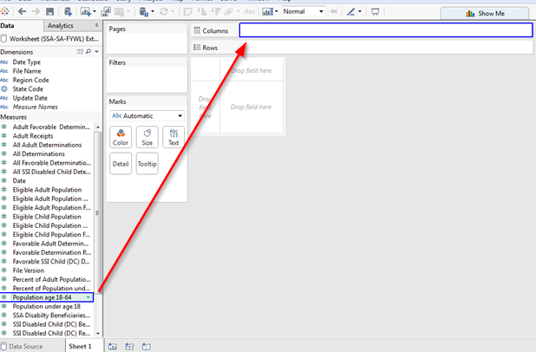
As a Rows we will use “State Code” or “Region Code”.
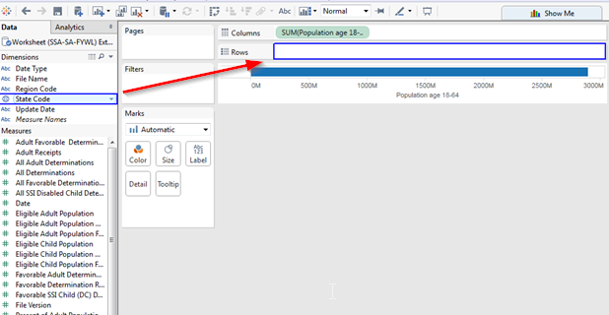
Now our sheet is ready for practice with grouping.

Create groups
Groups
Visually Grouping Data
Hierarchies

For create some group you need to press and hold “CTRL” button and select by mouse couple rows from our sheet.
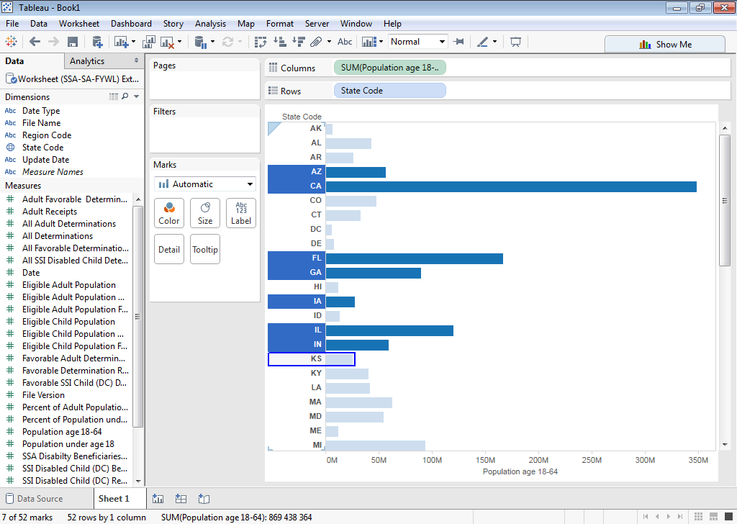
After selection, not selected rows will be grayed and selected will have stronge color. Now it’s only selection, not a group. For creation a new group right click on selected rows and at context menu and click on Group menu.
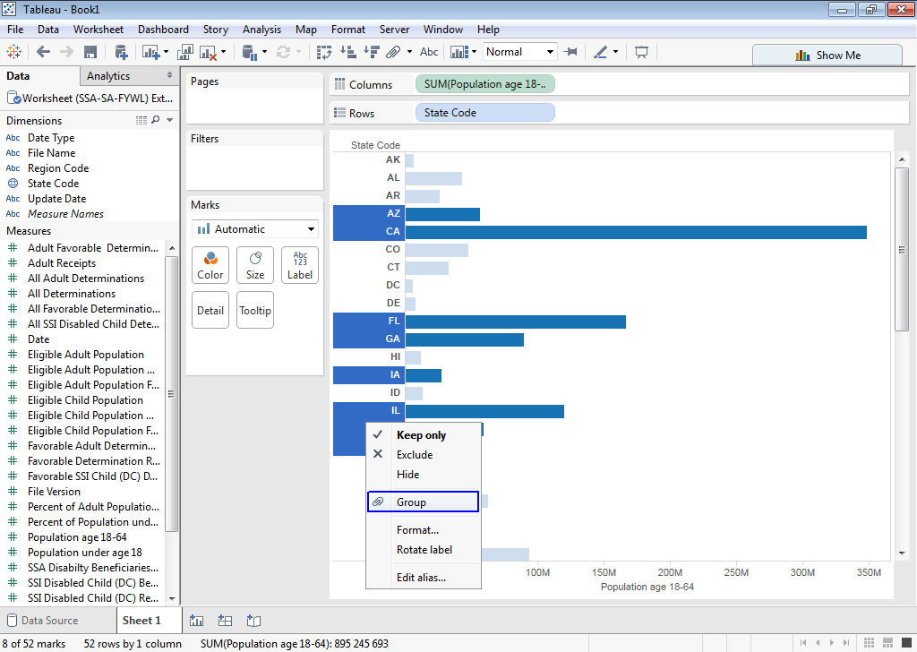
Now at left panel at Dimensions you will see new group with name “State Code (group)”.
You can change group name by right click on group and at context menu select “Edit group…”. At modal window you have possibility to change a name at Field Name text block. Group sub-groups, change and upgroup them.
For ungroup cyrrently created group at main worksheet click on groupped row and click on Ungroup Members. It will clear our groups at “State Code (group)”, all our grouping hace no impact to main Dimension “State Code” and performs at auto-generated “State Code (group)” group.
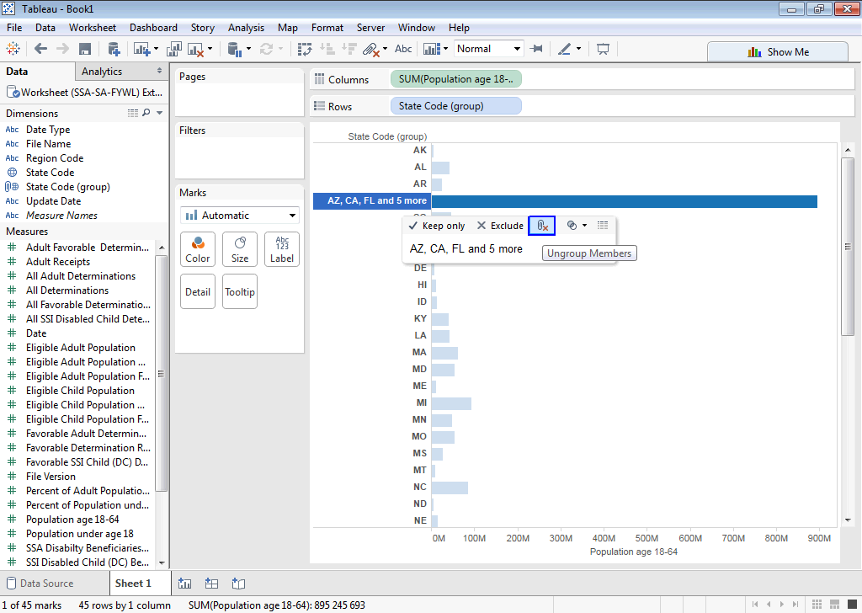
Groups
Visually Grouping Data
Hierarchies
At next chapter we will see more deeply for generating groups and use them like a filters.

Visually grouping data

Create and modify sub-groups

Select “Edit group…” at context menu for our tesing group. At opened modal window we can see all data memers. For that members we have available only one option from a start – Group, after it all other will be available.
Select some item and press Group button.
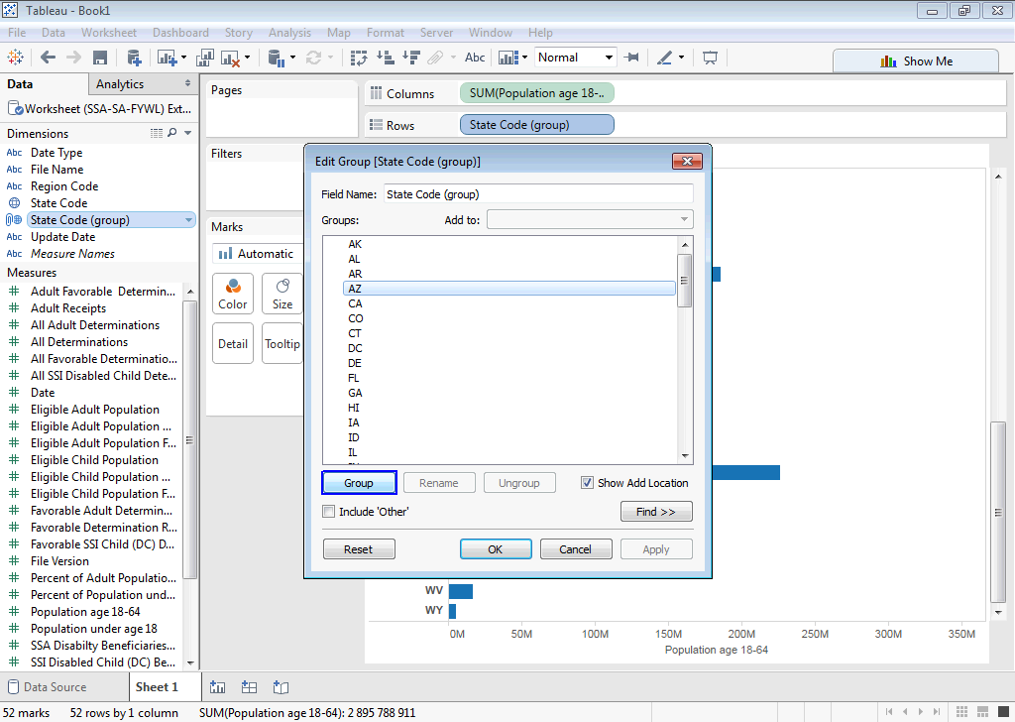
After it will be created sub-group with name equal to selected item with that item inside.


Groups
Visually Grouping Data
Hierarchies
From a start, you will have possibility to change group name. You can make it later by click on group and press Rename button. Also, you can see that look-up Add to is become editable and selected value is equal to selected group.
button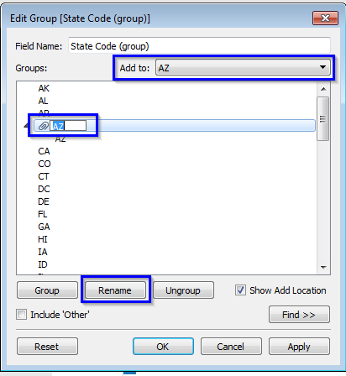
Also, you can Drag and Drop other elements from collection into created group. If name was not changed, it will be regenerated and contains all names from a collection, but if names was more than four it will have next view:
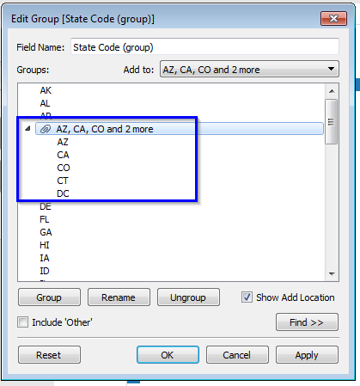
Groups
Visually Grouping Data
Hierarchies
You can also create a group by selecting a range of items by Ctrl + Click and press Group button. After such action, group will be created in the same ways as with Drag and Drop.
For ungroup you can use Drag and Drop or Ungroup button.
With Drag and Drop you just need to take from a group item outside the group branch. But with Ungroup button we have couple behaviors:
- You can use Ungroup button for single element in the group. For it just click on single element at group
- You can use Ungroup button for multiply elements. For it just select by Ctrl + Click set of elements.
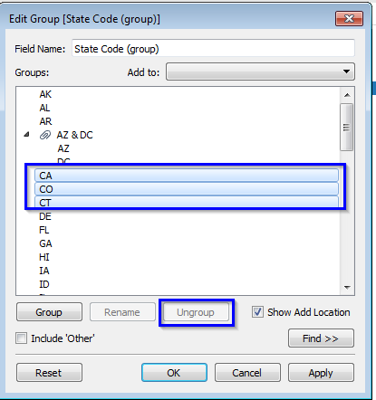

Groups
Visually Grouping Data
Hierarchies
- Or can use Ungroup button for a full group, for it just click on group name and press Ungroup
- button.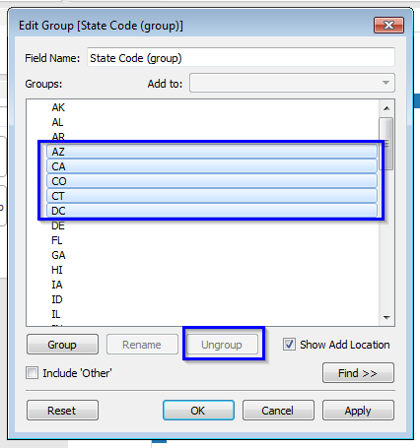

Use group as filters

For using created groups like a filter just Drag “State Code (group)” and Drop into Filters region. Right click on it and select “Edit filer…”
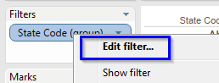

Groups
Visually Grouping Data
Hierarchies
At opened dialog:
Groups
Visually Grouping Data
Hierarchies
- Press None button for unselect all elements.
- Select only group elements.
- Apply changes and press OK for approve the filter.
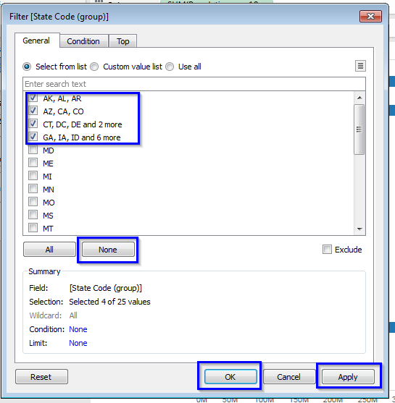
Now you will see that at main worksheet only groups from filter are available.
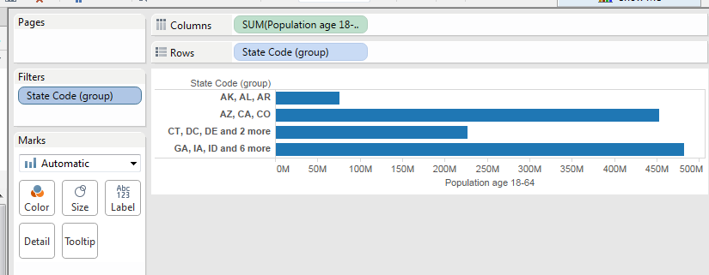

Save result you can get if you will use Ctrl + Click at worksheet for grouped rows and click on “Keep only” for them. It will create same filter as we done it manually. 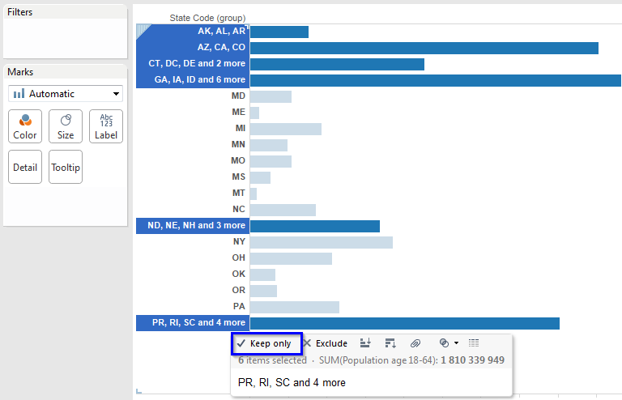
Groups
Visually Grouping Data
Hierarchies

HIERARCHIES
Groups
Visually Grouping Data
Hierarchies

Create HIERARCHIES

Hierarchies view is available only for Dimensions area. If you need to use it for some Measures you should drag it and drop inside the Dimensions region. It will be removed from Measures and available for using not like a summary of values but in same way as other string fields at Dimensions.
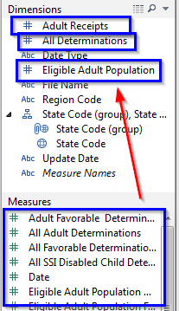
For create some hierarchies view we should drag some Dimension field and drop over other one. After such action, will appear dialog for entering new hierarchy group for this two fields.
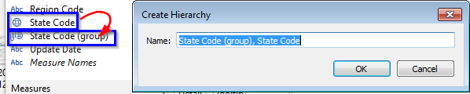
This already created hierarchy view for that elements.
When you drag a member of the hierarchy to the view, you can use the plus and minus (+/-) buttons on the field on the shelf to drill through the levels.
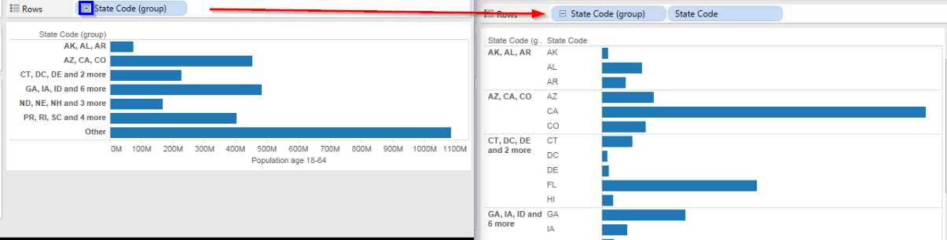
Groups
Visually Grouping Data
Hierarchies

Discrete Custom Date Hierarchy (Years to dates)

- Go to Data Source.
- Find Adult Receipts column – this column will be changed to Date, because generated date’s will have a large range, good for example.
- Convert from Number (Whole) into Date data format.
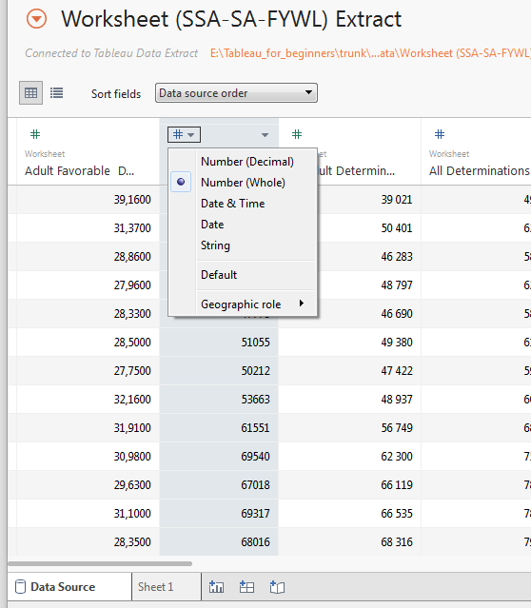

- Go back to Sheet1.
- At Dimensions find Adult Receipts field.
- Right click on it. At context menu click on Create => Custom date…
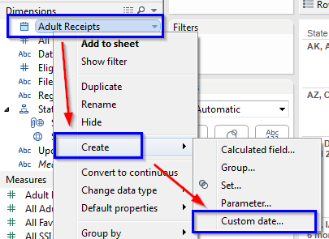
- In the Create Custom Date dialog box, name the custom date " Adult Receipts (Discrete Years)", select Years from the Detail drop down list, select Date Part, and then click OK.
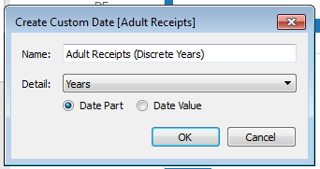
- In the Data pane, drag Adult Receipts (Discrete Years) on top of Adult Receipts to create a hierarchical group.
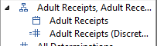
Groups
Visually Grouping Data
Hierarchies
- Drag newly created hierarchy into the column region and “Population age 18-64” into rows region.

- Change view type for lines (continuous).
Groups
Visually Grouping Data
Hierarchies
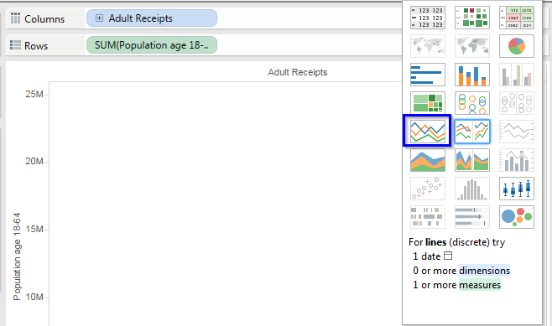
- Change view size into Fit width.
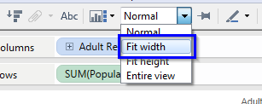
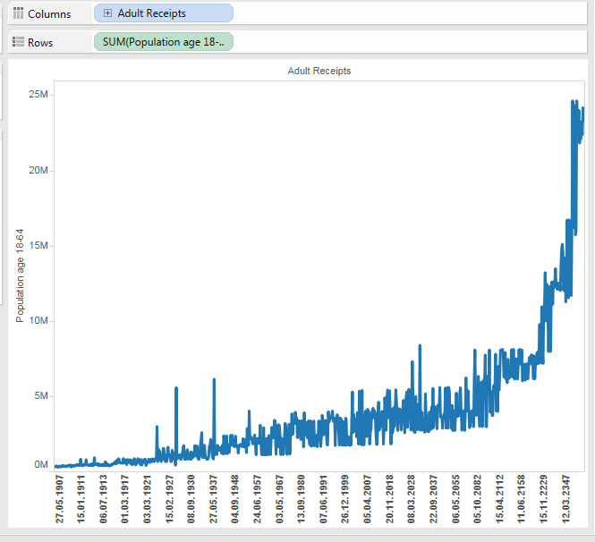

- Expand Adult Receipts to show booth Years and full Dates.
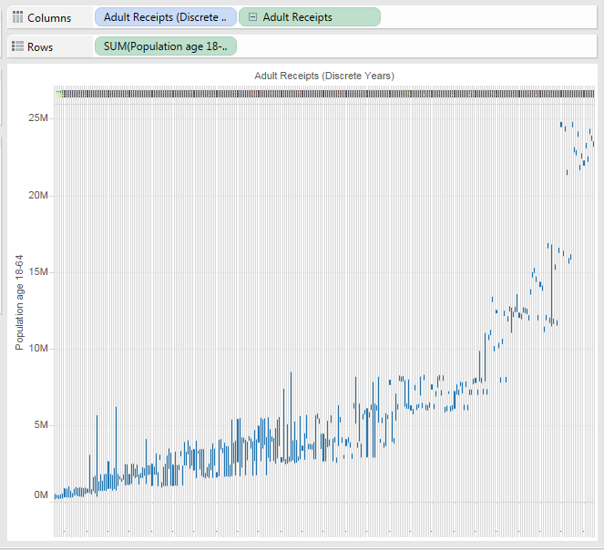
- Now you can use Ctrl + Mouse wheel up/down for see more detail sat the output view. Also, you can use double click or mouse selection.

Groups
Visually Grouping Data
Hierarchies

